**Pre – Requisite:** Ensure that Emp and Dept tables are created as below and it contains records.

Tables must be created as ZXXXXXXDEPT and ZXXXXXXEMP, where XXXXXX is your empcode.

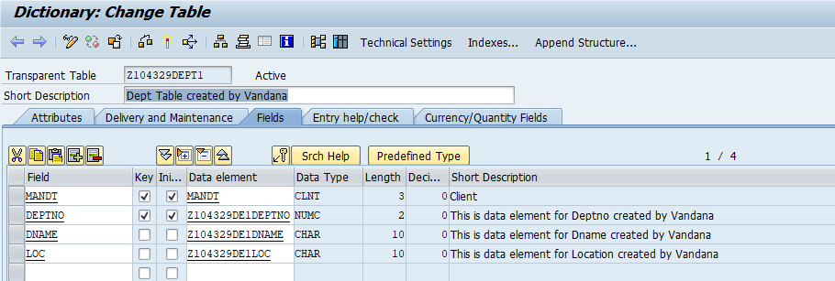

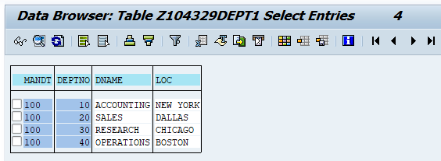

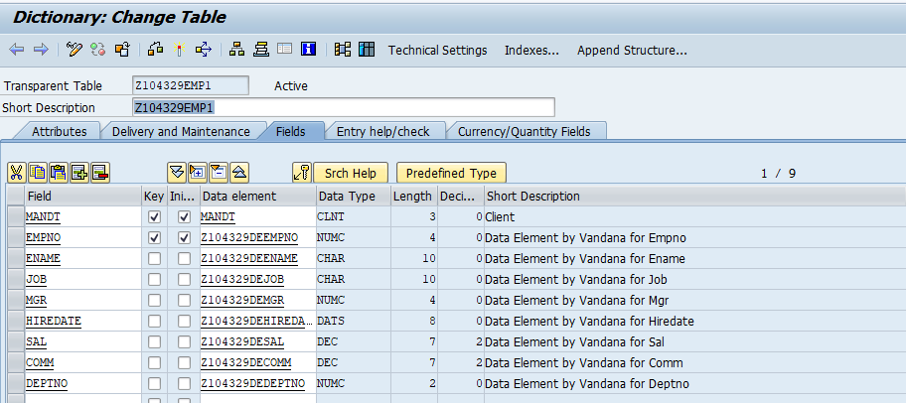

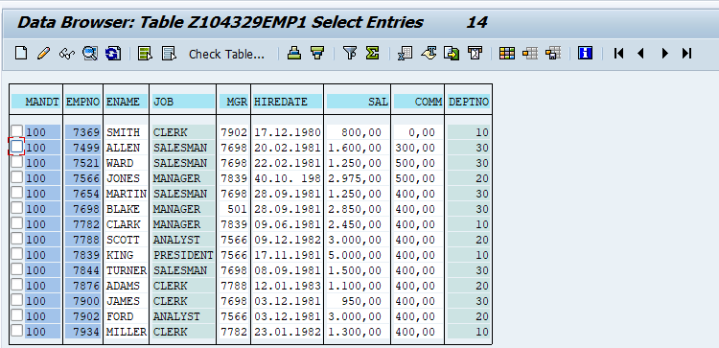

There **must** be relationship between Emp and Dept tables. **This is mandatory.**

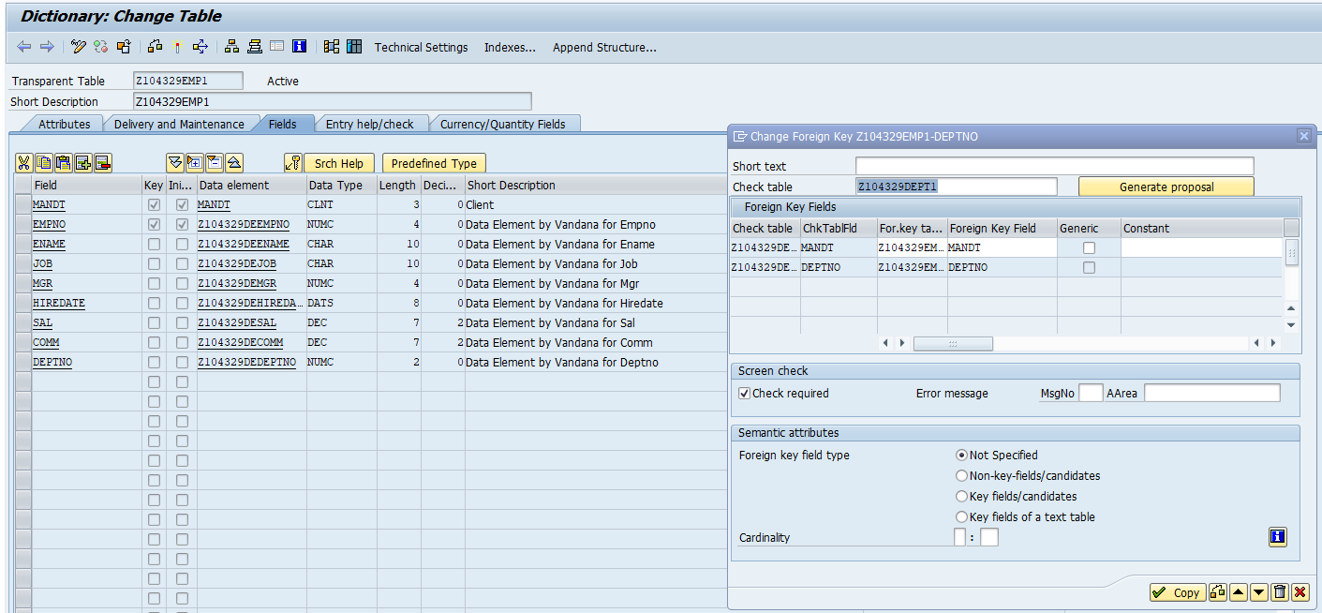

Create Maintenance view based on 2 tables.

1. Enter the table name as shown below. Click on Relationships.

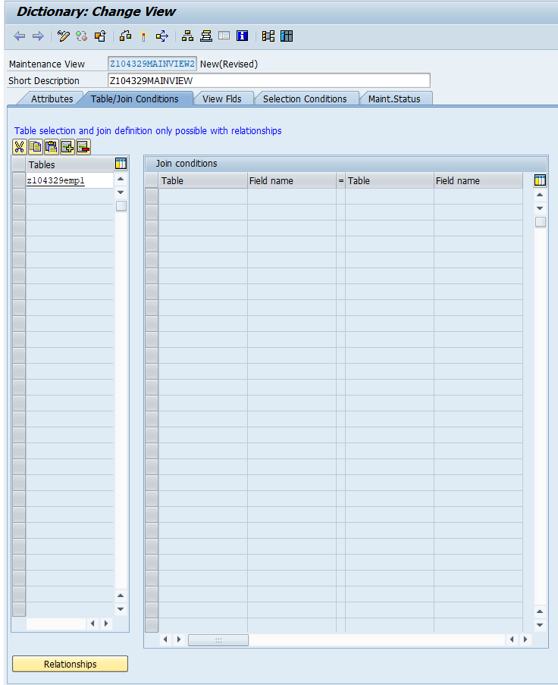

1. Select the check box.

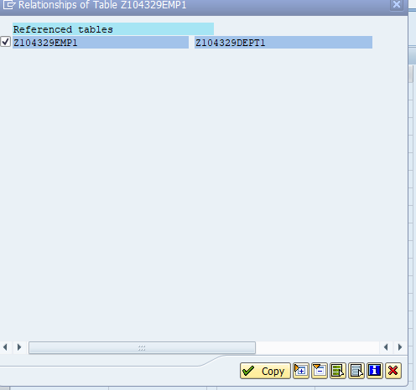

1. The relationship will be created as shown in screen below.

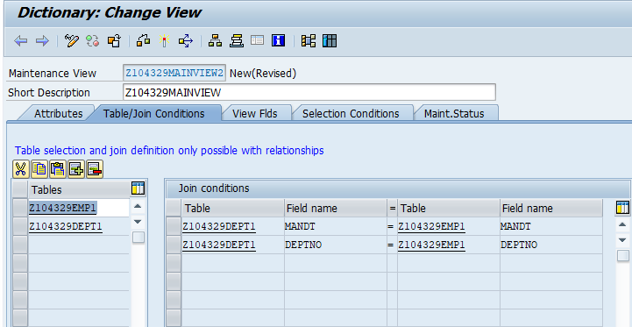

Note: Join conditions **CANNOT** be manually entered the way it can be done in Database view.

1. Click on View Fields tab. Click on Table Fields. Choose Emp1 table as shown below.

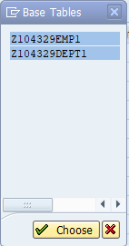

1. Select Fields as shown below and click on copy.

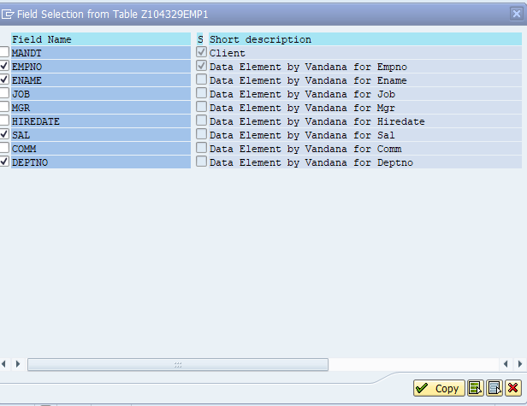

1. Similarly select fields from Dept table. Deptno field is present in both tables. In the view, we are selecting deptno from both table. The fieldnames cannot be deptno in the view, else it will result in ambiguity.

Hence, to distinguish the field is prefixed with the name of the table. E.g Emp_Deptno and Dept_Deptno.

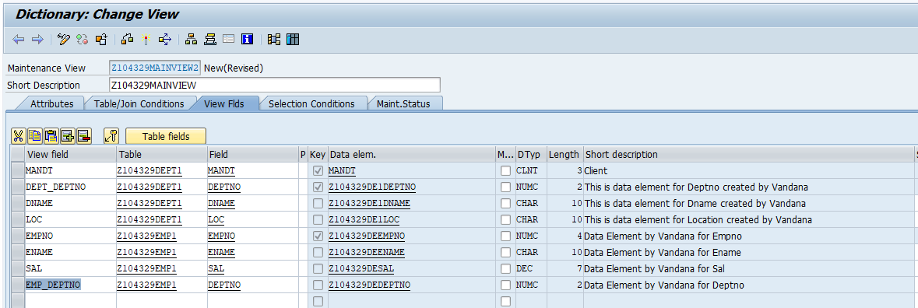

1. View the records.

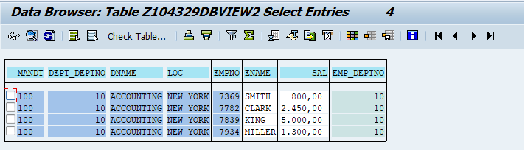

1. Observe the maintenance status.

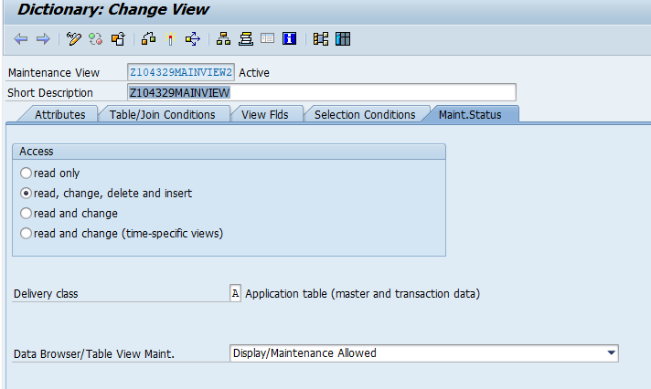

1. You cannot see the contents of Maintenance view. In case , you do it shows message as shown below.

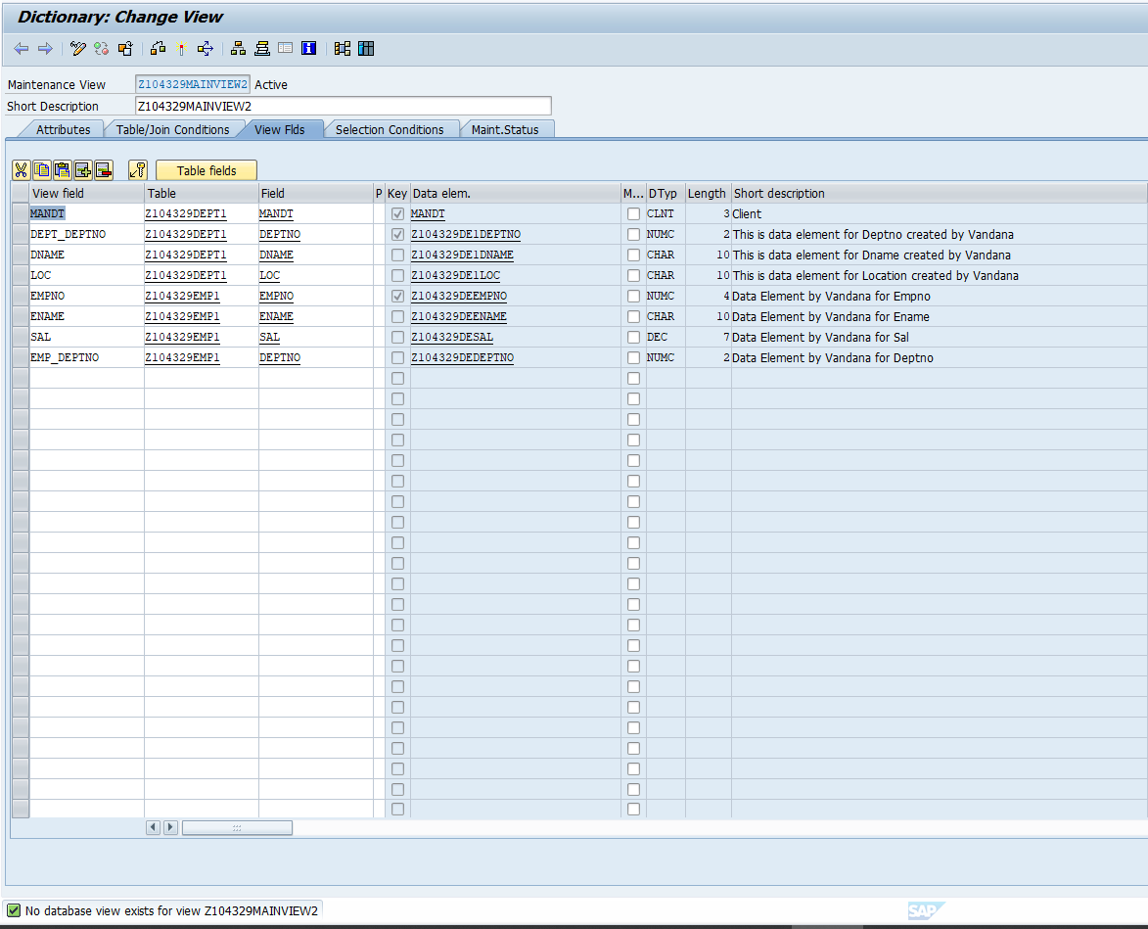

1. Create a TMG for Maintenance View. Then you can see records.

Go to Utilities- Table Maintenance Generator. Select Authorization group.

Enter appropriate Function group. Eg ZXXXXXXFGY

Where xxxxxx is your empcode and Y is any number eg. 1/2/3

To indicate that a new function group is created here.

Select Radio Button one step. Click on Find screen numbers.

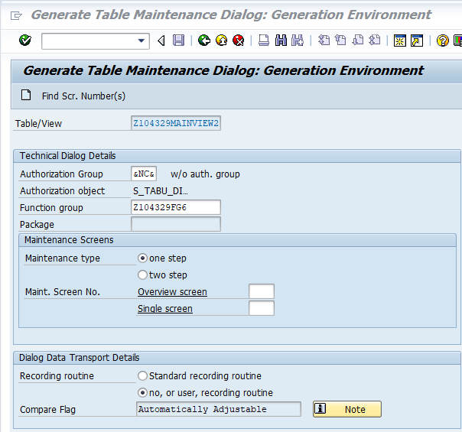

Select Ration button Propose Screen Numbers. Click on create.

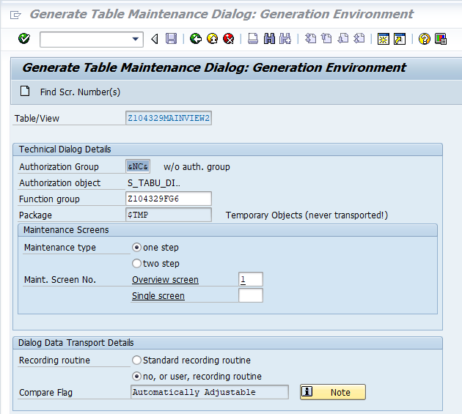

Now you can view the contents of the Maintenance view.

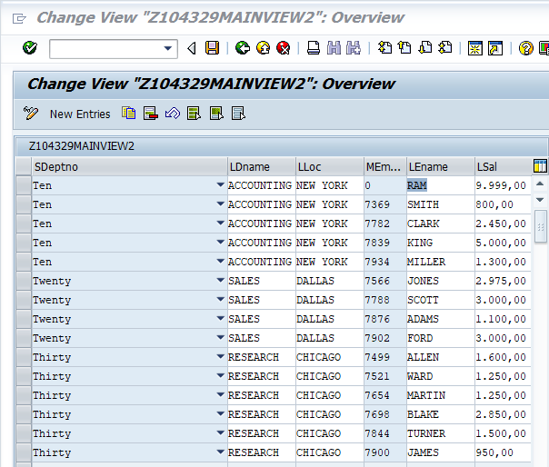

You can modify the contents of Emp table. Check this.

Add a record. Check this.